
COLEGIO PEDRO DE VALDIVIA DE VILLARRICA
Departamento de Inglés
Miss Angélica Arévalo R.
Programa de integración
Rayen Romann
Curso: 7º y 8º Básico

READING Nº 2 “MY SMARTPHONE IS COOL”
ENGLISH

NAME:
CLASS: |  | DEADLINE |  | April 3rd, 2020
OBJETIVO DE APRENDIZAJE Nº 10  - Demostrar comprensión de textos no literarios al identificar:  • propósito o finalidad  • ideas generales, información específica • palabras y frases clave, expresiones de uso frecuente y vocabulario temático  • conectores |  |  | HABILIDADES DEL O.A |  | HABILIDADES DE LA GUIA
 |  |  | Reconocer vocabulario clave |  | X
 |  |  | Identificar propósito o finalidad de texto |  | X
 |  |  | Identificar ideas generales e información específica. |  | X
 |  |  | Identificar vocabulario clave, expresiones de uso frecuente y conectores |  | X
 |  |  | Distinguir entre opinión o hecho |  | X
INSTRUCCIONES
Estimado estudiante:
Si te surge alguna interrogante en relación a la realización de esta guía no dudes en consultar, tus profesoras:
Profesora de inglés: Miss Angélica Arévalo R. escribiendo al correo angelicaarevalor2018@gmail.com
Profesora Diferencial. Rayen Romann G. escribiendo al correo rayenromann@gmail.com
Estaremos disponibles para resolver tus dudas. Además, puedes enviar tu guía resuelta
(con tu nombre y curso) al correo, para poder revisarla.

I. MIRA las imágenes y ESCRIBE adjetivos que las identifiquen.
LOS ADJETIVOS NOS ENTREGAN CARACTERISTICAS
EXAMPLE =
Useful: útil
Bad: Malo
Beautiful: Precioso

EXAMPLE =


- Necessary : Necesario
- New: Nuevo
- Modern: Moderno
- Fast: Rápido
- Gray. Gris

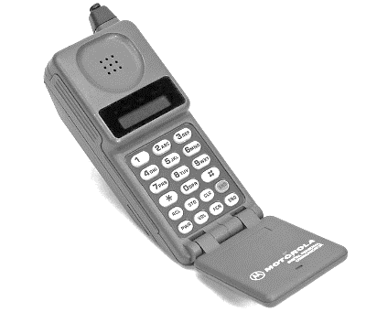

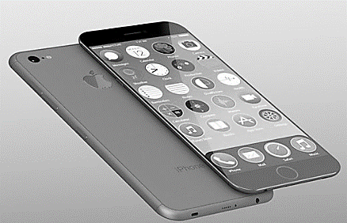

II. ESCRIBE una definición en INGLÉS o SPANGLISH para las siguientes palabras.
1. Smart
2. Features
3. Run
4. Allow
5. Advance


III. LEE el siguiente texto y SUBRAYA las palabras del ítem II. Además usando otro color SUBRAYA aquellas palabras o frases relacionadas con tecnología.

Recuerda que para una mejor comprensión debes subrayar las palabras importantes y buscar en el diccionario aquellas palabras que no conoces
Well, you're not alone. How is a smartphone different than a cell phone, and what makes it so smart?
In a few words a smartphone is a device that lets you make telephone calls, and also adds in features that, in the past didn’t exist. In general, a smartphone will be based on an operating system that allows it to run applications. Apple's iPhone runs the iOS, and BlackBerry smartphones run the BlackBerry OS. Other devices run Google's Android OS, HP's WebOS, and Microsoft's Windows Phone. A cellphone is simply a telephone that doesn't need a landline connection. It allows the user to make and receive phone calls. Besides some cellphones also offer text messaging. Nowadays to have a cellphone like that must be really dull.
On the other hand, a smartphone has more advanced features, including web browsing, software applications and a mobile OS. In turn, a smartphone also offers capabilities such as support for biometrics, video chatting, digital assistants and much more. One of the most important features of a smartphone is its connection to an app store. An app store is a centralized portal where users can search for and download software applications to run on their phones; most of them are free but you can also find paid apps. A typical app store offers thousands of mobile apps for productivity, gaming, word processing, note-taking, organization, social media and more. The technology surrounding smartphones and cell phones is constantly changing, maybe in the future you will be able to even have a 3D printer in your phone. What constitutes a smartphone today may change by next week, next month, or until the next Steve Jobs is born.

IV. LEE el texto nuevamente. LEE las preguntas y elije la alternativa correcta.

1. What is the purpose of the text? ¿Cuál es el propósito del texto?
a) To inform about the latest Smartphones.
b) To describe the characteristics of a smartphone.
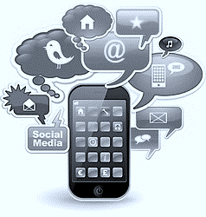
c) To define what are old and new phones.

2. In general terms a smartphone:
En términos generales un smartphone:
a) Can only make phone calls and send emails.
b) Doesn’t need connection to the internet.
c) Do similar things as a computer.

3. An app store is important because: Una tienda de aplicaciones es importante porque:
a) You can download music and pictures from there.
b) You can download software applications.
c) You can download only paid apps.

V. LEE el texto una vez más el texto y RESPONDE verdadero o falso. JUSTIFICA las falsas en inglés o spanglish.

- ____Cellphones in the past could only make phone calls.
______________________________________________
- ____ Smartphones don’t need a landline.
______________________________________________
- ____ All smartphones have an IOS operating system.
______________________________________________
- ____An advanced feature of a smartphone is video chatting.
______________________________________________
- ____Users of smartphones can download software applications from a “Store”.
______________________________________________

VI. ENCIERRA en un círculo los siguientes conectores SO –MAYBE-ALSO-UNTIL, que aparecen en el texto y ESCRIBE oraciones nuevas o tomadas del texto con cada uno de ellos.
UN CONECTOR ES UNA PALABRA QUE SIRVE PARA UNIR ORACIONES O IDEAS
SO –MAYBE-ALSO-UNTIL

SO = ENTONCES
MAYBE = QUIZÀS
ALSO = TAMBIÈN
UNTIL = HASTA

1.
2.
3.
4.

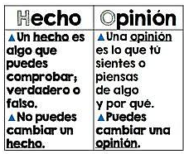
VII. LEE el texto por última vez y DISTINGUE si las siguientes oraciones son OPINIÓN o HECHO (OPINION or FACT).

1.You probably hear the term "smartphone" a lot.

2. A smartphone is a device that lets you make telephone calls.

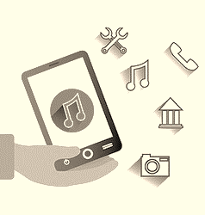
3. What constitutes a smartphone today may change by next week.

4. Nowadays to have a cellphone like that must be really dull.

5. An app store is a centralized



